
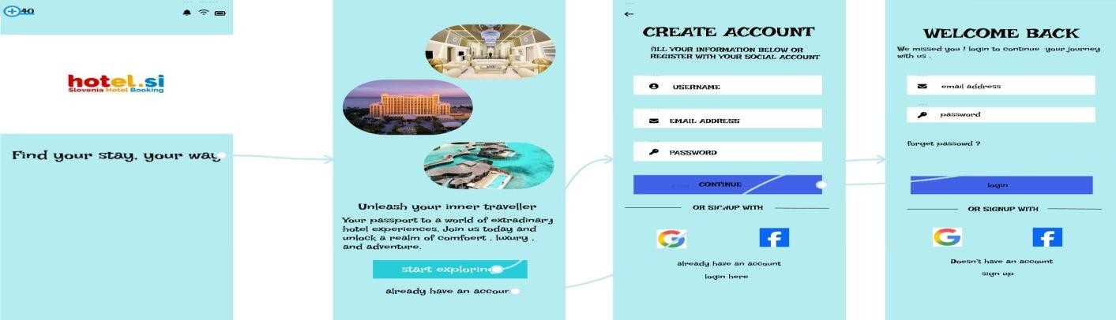
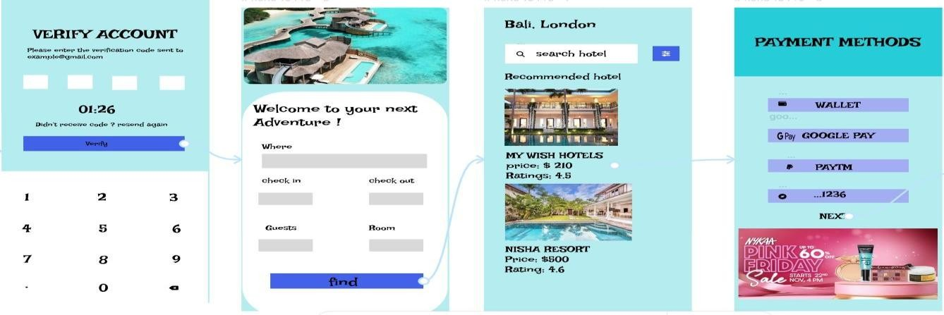


Name: David Anthony F(192421217)

HOTEL BOOKING
S
YSTEM

